Cloud Computing Project Report

Michael Brennan

x10381695

# Introduction

InfoSeeker is a simple project that provides weather data and news of a selected city. Right now the app only contains three cities but I hope to expand this in the future.

# Technical Overview

## User Interface Design

The app contain a top bar which contains the names of the three cities located on the web app. Further down you will find two sections one called Weather and The other called news. In the weather Column, the current weather for that city is displayed with visual aids.

In the second column, News for that city is displayed in list view. It is displayed in simple text format. The news comes for the local news source of that city. So for Dublin it is RTE, London is BBC and New The news comes for the local news source of that city. So for Dublin it is RTE, London is BBC and New York is CNN. This information is updated dynamically as it happens.

## Data Source 1, Weather Data

I developed a simple PHP script that retrieves PHP data from Yahoo Weather API. The PHP identifies the city code and then relays that data back to the user.

Below is an example of how that data is displayed. The File communicates with the server and displays the current weather, the current Temperature and Wind speeds. The main data is from an external PHP file called “jweather.class.php”. This php file help with the retrieval of weather data. Each city identified with a unique code.

Below is a screenshot of how this works:

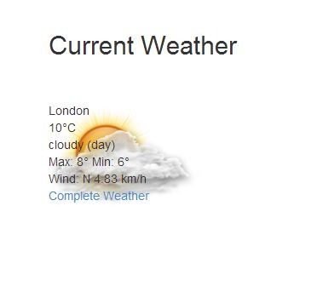

And a code snippet:

C:\Users\Mick\Pictures\vvvv.JPG

## Data Source 2, News Data

My second source is news data. It parses an RSS feed from the data source and then parses that data displaying it on the web page. Below is a code snippet of how this works. For Dublin News is sourced from RTE News, London is BBC London and New York is New York Times

Screenshot:

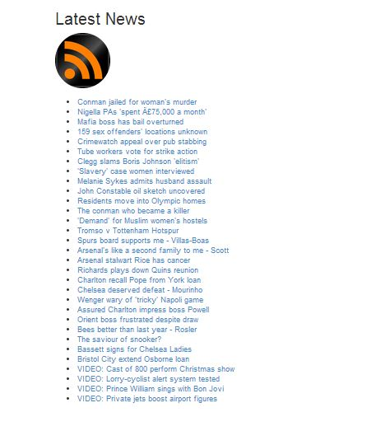

Code: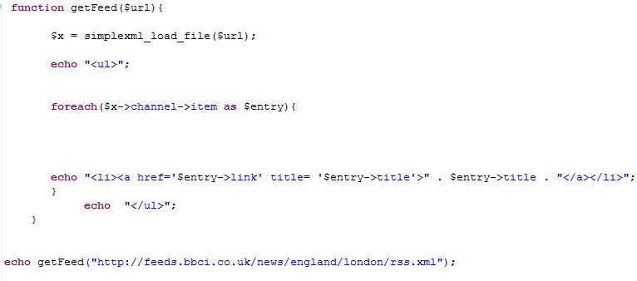

# Deployment strategy

In the end I decided to use PHP cloud and Red Hat with OpenShift to host my web app. There were various challenges associated with each. Here I will explain:

## Platform One

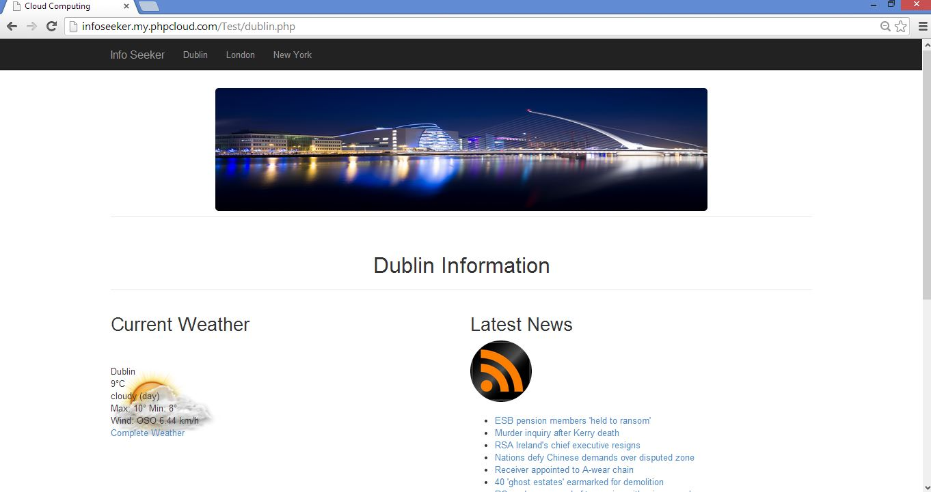

I decided to settle on PHP cloud for my first app. The steps involved downloading the Zend framework onto my laptop and installing the software. I then loaded the files onto the framework. I set up a PHP cloud account and then was assigned a URL to host my project. In Zend I dropped these files into the cloud space and the web app went live.

Here is the link:

<http://infoseeker.my.phpcloud.com/Test/index.php>

## Platform Two

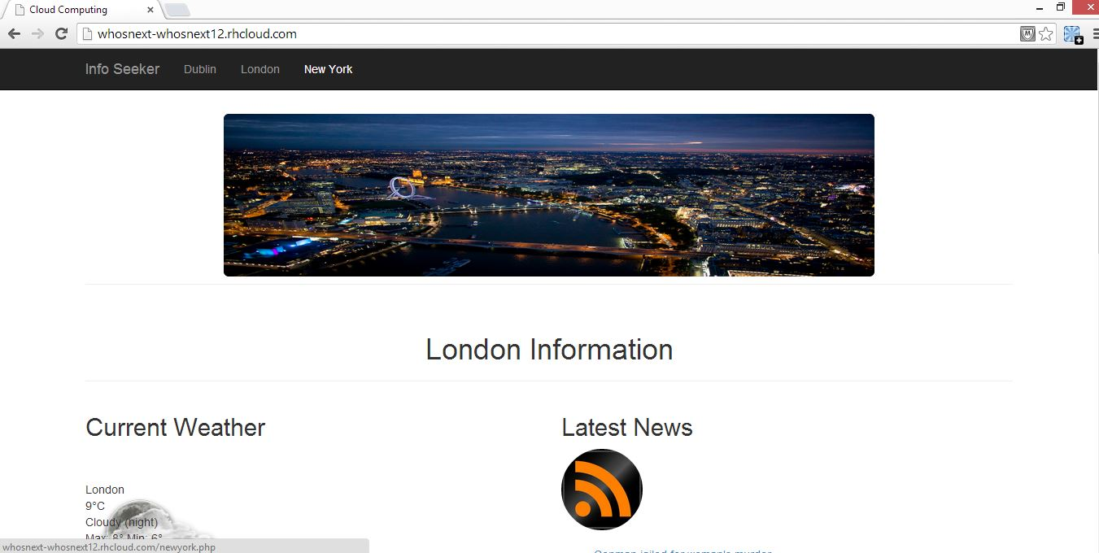

The second one I used was Red Hat. For this deployment strategy I used an online IDE known as Code Envy. You set up a project and you connect with the cloud provider in that. So I uploaded the files to code envy login in to open shift and hosted the web app on the assigned URL.

Here is the link:

<http://whosnext-whosnext12.rhcloud.com/>